The St. Vincent de Paul Back2Work program develops and strengthens skills to support job seekers entering or re-entering the workforce.

Workplace communication Job interview practice St. Vincent de Paul partners with employers to connect Back2Work participants with employment opportunities

Our class will include:
Resume development -Job interview practice

-Guided career search -Workplace communication
Orientation Required

Where: Thurs. Sept. 17 11:00 am – 12:00 pm
St. Vincent de Paul Education Center (2nd floor)
1426 6th Ave., Des Moines 50314

Class Dates and times:

Wednesday Sept 23 9:00 am - 3:00 pm
Thursday Sept 24 9:00 am - 3:00 pm
Friday Sept 25 9:00 am - 3:00 pm
Monday Sept 28 9:00 am - 3:00 pm
Tuesday Sept 29 9:00 am - 3:00 pm
Wednesday Sept 30 9:00 am - 3:00 pm

Space is limited! Register for Orientation by scanning the QR code or
email or mike.collet@svdpdsm.org or call Mike at 515-282-8327 ext. 220
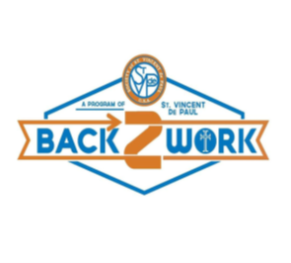
mike.collet@sdpdsm.org
8 ext. 220
Scan?
mike.collet@svdpdsm.org
515-282-8328 ext. 220
Scan to

