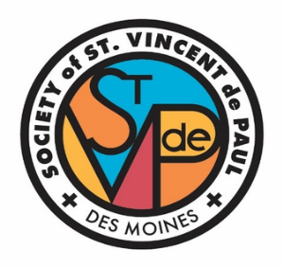
The St. Vincent de Paul Back2Work program develops and strengthens skills to support job seekers entering or re-entering the workforce.

Workplace communication Job interview practice St. Vincent de Paul partners with employers to connect Back2Work participants with employment opportunities

Our class will include:
-Resume development -Job interview practice


-Guided career search -Workplace communication
-Guest speakers -Resource navigation
Orientation Required:

When: Thurs. Nov. 5 11:00 am – 12:00 pm
Fri. Nov. 6 11:00 am – 12:00 pm
Mon. Nov. 9 11:00 am – 12:00 pm

St. Vincent de Paul Education Center (2nd floor)
1426 6th Ave., Des Moines 50314

Class Dates and times:

Wednesday Nov 11 9:00 am - 3:00 pm
Thursday Nov 12 9:00 am - 3:00 pm
Friday Nov 13 9:00 am - 3:00 pm
Monday Nov 16 9:00 am - 3:00 pm
Tuesday Nov 17 9:00 am - 3:00 pm
Wednesday Nov 18 9:00 am - 3:00 pm

Space is limited! Register for Orientation by scanning the QR code or
email or mike.collet@svdpdsm.org or call Mike at 515-282-8327 ext. 220

mike.collet@sdpdsm.org
8 ext. 220
Scan?
mike.collet@svdpdsm.org
515-282-8328 ext. 220
Scan to

