The St. Vincent de Paul Back2Work program develops and strengthens skills to support job seekers entering or re-entering the workforce.
St. Vincent de Paul partners with employers to connect Back2Work participants with employment opportunities
Career readiness skills include:
-Resume development -Job interview skills practice
-Guided career search -Workplace communication
Orientation Required
Thursday, June 11 11:00 am – 12:00 pm
Where: St. Vincent de Paul Education Center (2nd floor)
1426 6th Ave., Des Moines 50314
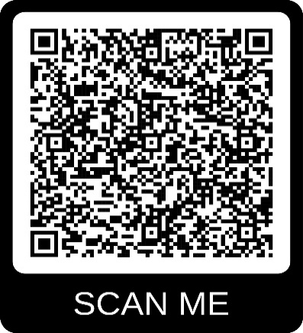
When:
Thursday June 18 9:00 am - 3:00pm
Friday June 19 9:00 am - 3:00 pm
Monday June 22 9:00 am - 3:00 pm
Tuesday June 23 9:00 am - 3:00 pm
Wednesday June 24 9:00 am - 3:00 pm
Thursday June 25 9:00 am - 3:00 pm
Scan the code to email Mike to register for joining
the class
Register for Orientation by;
Emailing mike.collet@svdpdsm.org or
calling Mike at 515-282-8327 ext. 2205515
mike.collet@sdpdsm.org
8 ext. 220
Scan?
mike. collet@svdpdsm.org
515-282-8328 ext. 220
Scan to

